IMAGES OF THE SYSTEM:

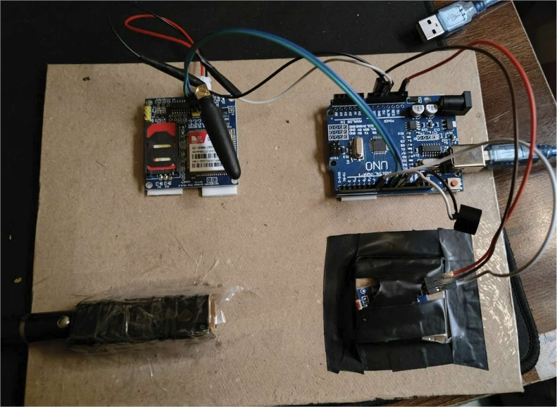

FIG 6 : Intruder detection System

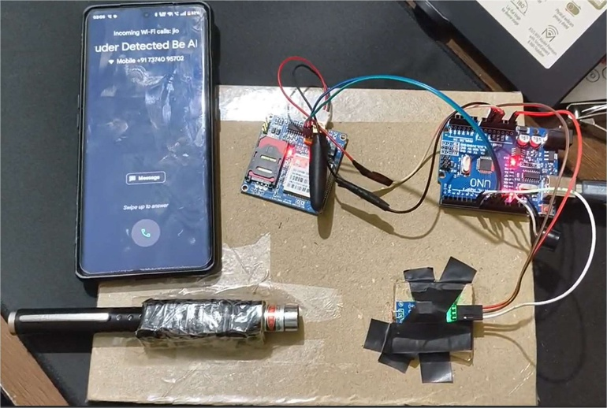

FIG 7 : Intruder detection System ( phone call notification )

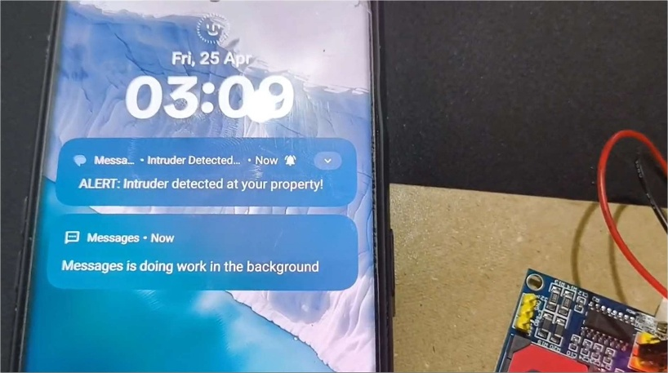

FIG 8 : Intruder detection System ( SMS notification )